**DISEASE TRIANGLE OF EARLY BLIGHT DISEASE OF TOMATOES (*Alternaria solani*)**

**EARLY BLIGHT (*Alternaria solani*)**

**PATHOGEN HOST**

**FUNGI(*Alternaria solani*) TOMATOES**

**ENVIRONMENT**

**Warm and Humid Climate, Overhead Irrigation,**

**Plant Density and Air Circulation, Plant Stress and Infected Crop Debris**

**LIFE CYCLE OF *Alternaria solani***

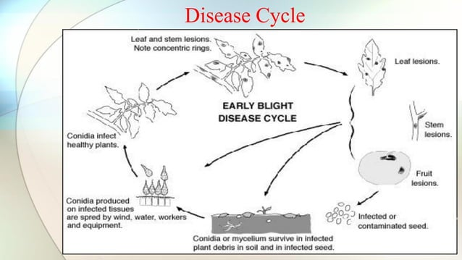

*Alternaria solani*, commonly known as early blight, is a fungal pathogen that affects tomato plants. We'll discuss the pathogen, its biology, and the conditions that favor the development of early blight.

**Pathogen:** *Alternaria solani* is a fungal pathogen belonging to the genus *Alternaria*. It primarily affects solanaceous plants, especially tomatoes, but can also infect other crops like potatoes and peppers.

**Biology:** *Alternaria solani* primarily survives as spores on infected plant debris, in soil, or on infected seeds. In favorable conditions, the spores germinate and infect the plant. The fungus produces dark brown to black lesions on leaves, stems, and fruit. These lesions may be circular, typically with a yellow halo surrounding them. As the disease progresses, the lesions expand and may coalesce, leading to foliar blighting and fruit rot.

**Host**: *Alternaria solani* primarily affects tomato plants *(Solanum lycopersicum).* However, it can also infect other members of the Solanaceae family, such as potatoes *(Solanum tuberosum)* and peppers *(Capsicum spp.).*

**Growing Conditions:** Several factors favor the development of early blight:

1. Warm and Humid Climate: Warm temperatures ranging from 24-29°C (75-85°F) and high humidity provide optimal conditions for the disease. Fungal spores require moisture to germinate and infect the plant.

2. Overhead Irrigation: Splashing water from overhead irrigation or rain facilitates the spread of fungal spores, increasing the chances of infection.

3. Plant Density and Air Circulation: High plant density without proper spacing leads to reduced air circulation, which creates a favorable microclimate for the pathogen. It allows the spores to linger around the plant and increases the chances of infection.

4. Plant Stress: Stressed plants, whether due to poor nutrition, drought, or other diseases, are more susceptible to early blight. The fungus takes advantage of weakened plants and infects them more easily.

5. Infected Crop Debris: The presence of infected crop debris, such as fallen leaves or fruit, provides a source of inoculum for the next growing season.

**CONCLUSION**

To manage early blight, it is important to implement practices such as crop rotation, proper plant spacing, regular scouting, and removal of infected plant debris. Fungicides may also be used as a preventive or curative measure, following label instructions and appropriate timing.